9.40: a) In the expression of Eq. (9.16), each term will have the mass multiplied by 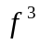and the distance multiplied by 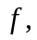 and so the moment of inertia is multiplied by 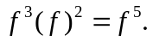 b) 